In order to begin using this IkFk switch node, the plugin must be loaded into Maya. Locate the ‘.mll’ file associated with the plugin and go into the plugin manager dialog. In Maya 2017 this is located at (Windows > Settings/Preferences > Plug-In Manager). When this window is open click browse and load in the ‘.mll’ plugin file. Make sure the plugin is loaded any time a scene using this plugin is loaded.

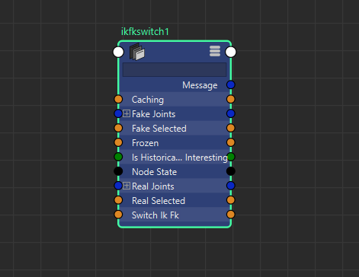 Once the plugin is loaded, open the node editor, in Maya 2017 this is located at (Windows > Node Editor). Create two joint chains and an Ik handle for one of them, or use two joint chains already constructed. Once this is done, the new node can be created and used. Press tab on the node editor and type in ‘ikfkswitch’ and press enter. This creates the new node. Open all the attributes of this node by right clicking on it and selecting ‘Show All Attributes.’ Your screen should look something like this.

Figure The New Node

The attributes ‘fake joints’ and ‘real joints’ shown above are where the message attributes of your ik and fk joints should connect. It doesn’t matter if the which joint chain connects to real or fake, but keep this consistent. To connect joints, the last joint in the chain should be at the zero index of the array, and move out from there. Below is an example of this.

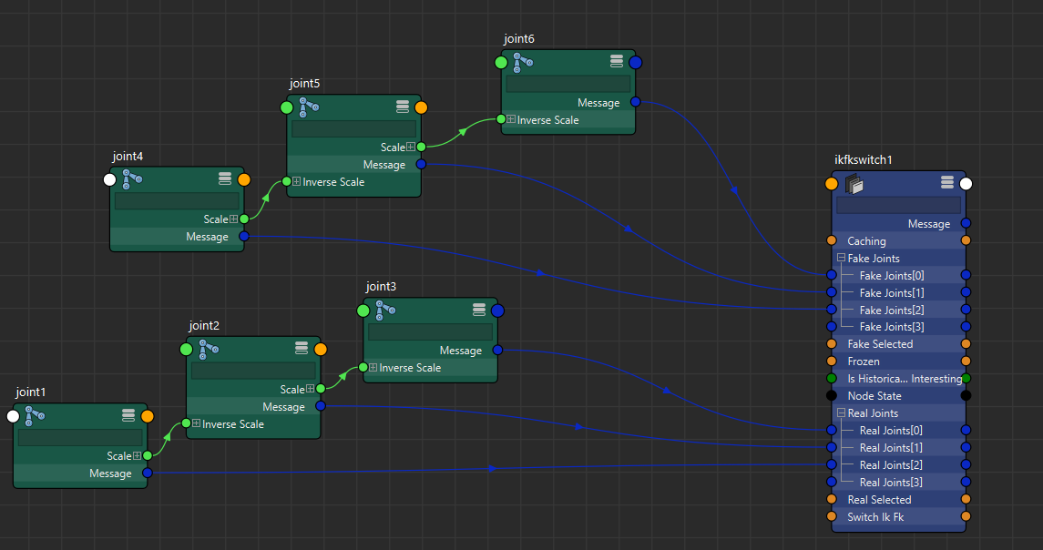

Figure Messages Connected

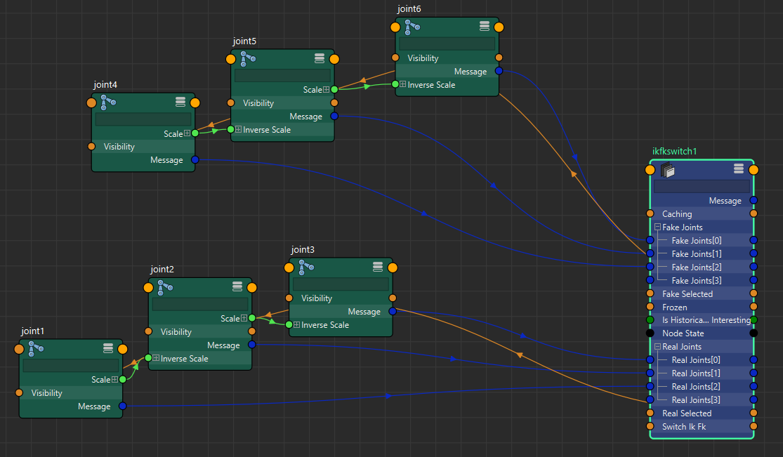Also notice the three Booleans, ‘real selected,’ ‘fake selected,’ and ‘switch ik fk.’ The first two should be wired up to all of your ‘visibility’ attributes of the respective joints, and the last controls which set of joints is visible. Below is a full example of the node hooked up.

Figure Visibility Connected